1. Open JIRA using your Login credentials
2. Go to <https://treasuryxpress.atlassian.net/projects>

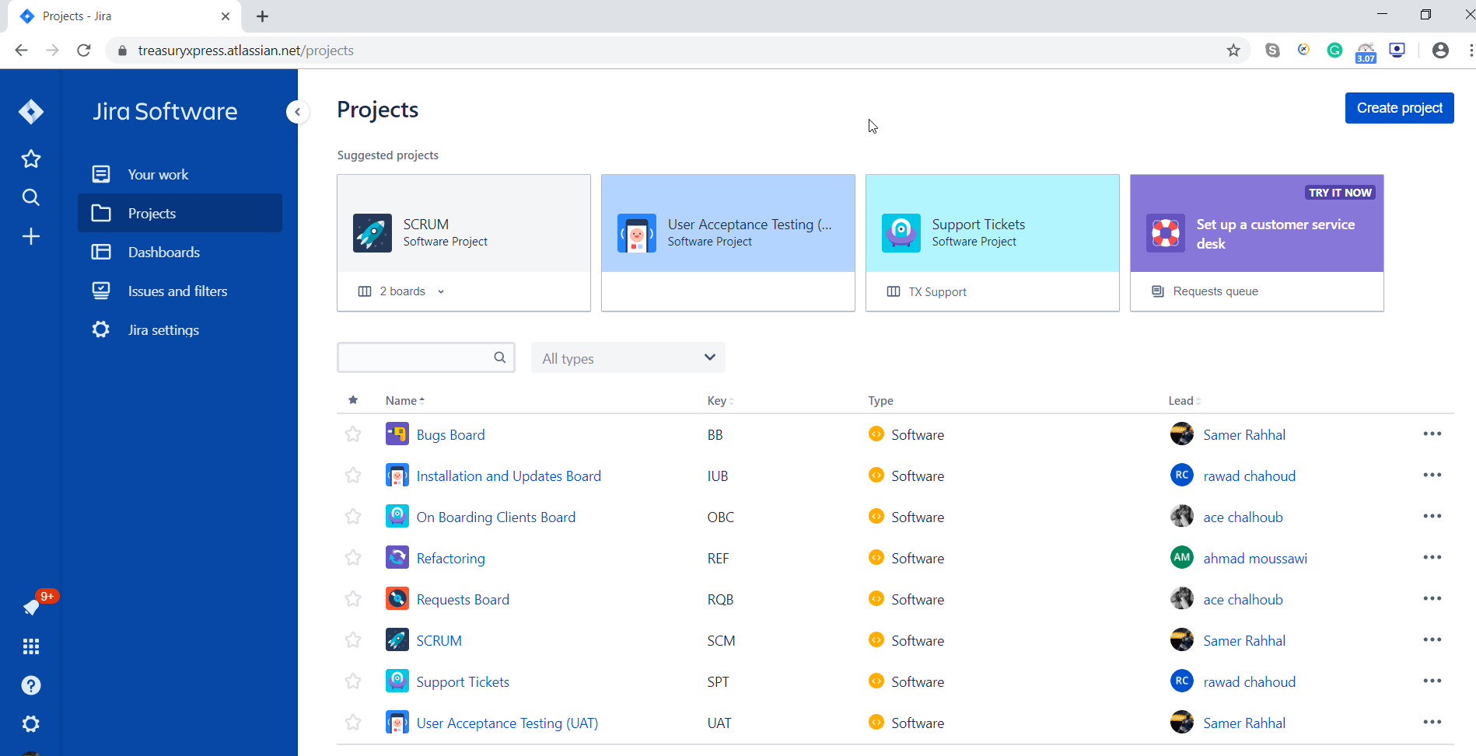

1. Select SCRUM Project
2. From Board menu on the left select “User Acceptance Testing”

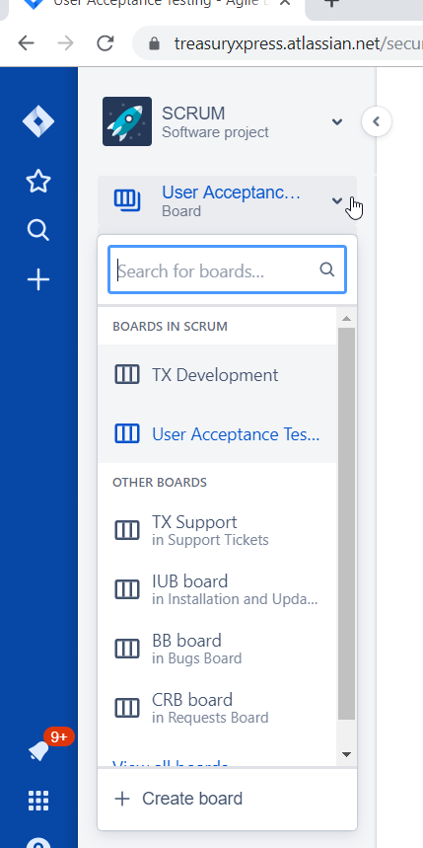

1. You will be redirected to a new board “User Acceptance Testing” as per below (This board is linked to Technical SCRM board).

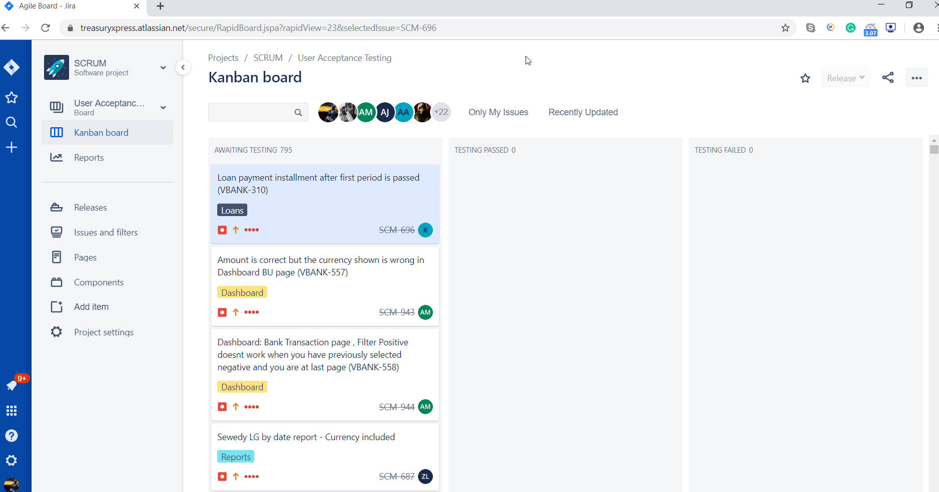

1. Three Phases are available
   1. Awaiting Testing 🡪 Case with Status Done in the SCRUM Development Board is automatically transferred here.
   2. Once the case is tested successfully from your end, it should be moved to Testing Passed, and in case of failure to Testing Failed
   3. QA Team will pick up the failed cases and coordinate with Business and Technical teams for further clarity and inquiries.

**NOTE: Ticket in Awaiting Testing will still be deployed on production environment, so kindly make sure to validate all your priority cases prior to the public deployment.**